Welcome to First Grade!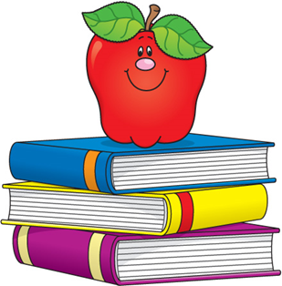

We are excited to see everyone back at school!

Most of the supplies your child will need (crayons, pencils, etc.) will be provided by his/her teacher.

Please make sure your child brings:

* A water bottle labeled with your child’s name. Bring water bottles every Monday. They will be sent home Friday.
* A backpack labeled with your child’s name.

If you would like to donate additional items to your child’s classroom, these items would be greatly appreciated!

* Ziploc baggies (gallon, quart, sandwich, and snack size)
* Kleenex
* Paper towels
* Disinfecting wipes
* Hand sanitizer

Sincerely,

Mrs. Bowman, Mrs. Jernigan, Ms. Lindberg

This will be a wonderful year for your child!

Thank you for your support!